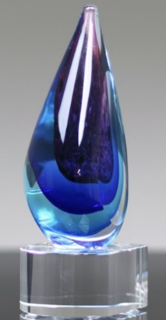
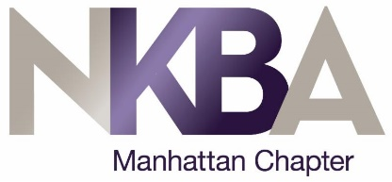
2020 NKBA Manhattan
ECO Awards

APPLICATION FOR NKBA SPONSOR MEMBERS
Inspiring our Communities through Environmental Leadership

NKBA Manhattan is pleased to honor our sponsors exhibiting best practices for environmental stewardship with our inaugural 2020 ECO Awards. We look to inspire not only our Sponsors but also our Members to consider and reduce their environmental impact.

Throughout the summer we would like to highlight some of the application we receive in bi-weekly emails, so let us hear from soon as possible!

Application Deadline: September 31, 2020
Award Presentation: Winter Awards to be announced
If you have questions, please contact Design@fodesign.info

Name

Company:

Phone:

Email

(Please highlight your preferred contact method above.)

A. Explain how your general company culture is impacted by the current global environmental consciousness.

B. How are you specifically inspiring NKBA Manhattan members to engage in sustainable living?

Examples: green events, showrooms; sustainability education; plant-based foods at events; green promotions or displays.

C. Feel free to elaborate about what your New York based business- showroom specifically does to inspire positive change.

For example, have you stopped using single use plastics? Do you reduce, recycle, reuse? Does your business compost? Do you use biophilia in your offices or showrooms? What do you do about electromagnetic pollution? Does your company offer a " used appliance buyback program" when customers purchase new units? Do you offer or have you switched completely to plant based food options at events? Do you have ECO specific events to inspire your customers? How about store displays or advertising to raise awareness? Do you donate to ECO funds or charitable groups? Do you use green building materials? Is your business climate neutral or LEED certified? Energy start certifications?

